HISTORICAL PLACES THAT WE WILL VISIT
MINIATURK
Miniaturk, the first miniature park in Istanbul, began in June 30, 2001. Miniaturk covers a total area of 60,000 square meters. Its model area is 15,000 sqm, making Miniaturk the world's largest miniature park in respect to its model area. The park contains 105 models done in 1/25th scale. 45 of the structures are from Istanbul, 45 are from Anatolia, and 15 are from the Ottoman territories that today lie outside of Turkey. The park hosts icons of many cultures and civilizations. Models vary from the Hagia Sophia to Selimiye, from Rumeli Fortress to Galata Tower, from Safranbolu Houses to the Sumela Monastry, from Qubbat As-Sakhrah to the ruins of Mount Nemrut. In addition, some works that have not survived into the present, such as the Temple of Artemis, the Halicarnassus Mausoleum and Ajyad Castle, were recreated.
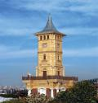
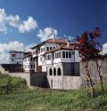
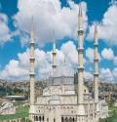
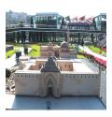

DOLMABAHÇE PALACE
Dolmabahçe Palace built in 19 th century is one of the most glamorous palaces in the world. It was the administrative center of the late Ottoman Empire with the last of Ottoman Sultans was residing there. After the foundation of the Turkish Republic in Ankara, Mustafa Kemal Ataturk transferred all government functions to the youthful capital but on his visits to Istanbul Ataturk occupied only a small room at Dolmabahçe Palace as his own. He stayed, welcomed his foreign guests and made a practical center for national, historical and language congress and for international conferences. Dolmabahçe palace has a great meaning for Turkish people since the supreme leader Mustafa Kemal Ataturk had used the palace as a residence and spent the most serious period of his illness and he passed away in this palace on 10 th of November 1938 at 9:05 AM, all the clocks in the palace are stopped at this time. Later on it was converted into a museum. It is wandered with a special sense of respect.
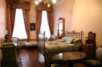
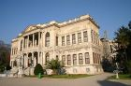
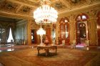

GÜLHANE PARK & ARCHEOLOGICAL MUSEUM
The Istanbul Archaeological Museums, a museum affiliated to the Ministry of Culture and Tourism, is located in İstanbul's Sultanahmet neighborhood, on the Osman Hamdi Bey slope connecting the Gülhane Park with the Topkapı Palace. The İstanbul Archaeological Museums, which is housing various artifacts from civilizations that had left their traces to different periods of the history, is one of the 10 most important world-class museums designed and used as a museum building. Additionally, it is the first institution in Turkey arranged as a museum. Besides its spectacular collections, the architectural aspects of its buildings and its garden are of historical and natural importance.
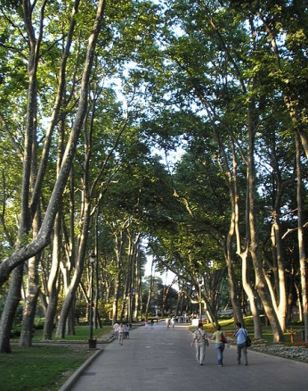
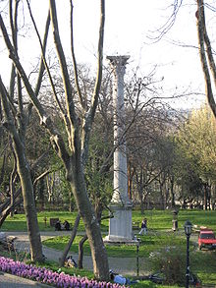
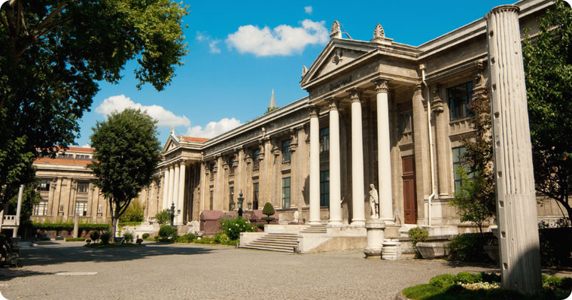

BASILICA CISTERN
This cistern is thought to have been built after the Nika revolt in 532 AD. It was known as the Basilica Cistern during the Roman period, as there was a Stoa Basilica above the pre-existing one at the time. After the conquest of the city by the Ottoman Turks, it was forgotten of and nobody knew that it existed. Re-discovered in 1545, it was used to water the gardens of Topkapi Palace. Today it has a rather eery and mystical ambiance. Clever spotlighting makes the water shimmer with coloured dancing lights and the water ripples from an occasional fish swishing its tail in exuberance.
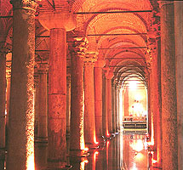
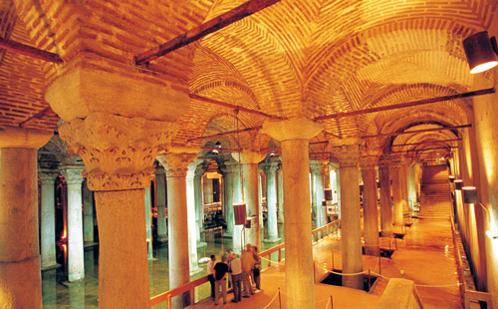

SULTANAHMET MOSQUE
The Sultan Ahmed Mosque (Sultanahmet Camii) is a historical mosque in Istanbul, the largest city in Turkey and the capital of the Ottoman Empire (from 1453 to 1923). The mosque is popularly known as the Blue Mosque for the blue tiles adorning the walls of its interior.
It was built between 1609 and 1616, during the rule of Ahmed I. Like many other mosques, it also comprises a tomb of the founder, a madrasah and a hospice. While still used as a mosque, the Sultan Ahmed Mosque has also become a popular tourist attraction.
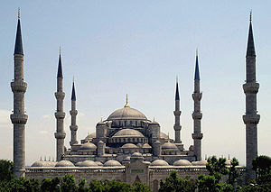
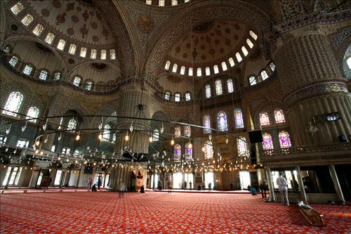

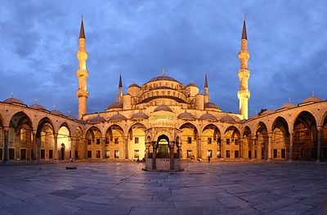

THE GRAND BAZAAR
The Grand Bazaar (Kapalicarsi in Turkish) is one of the the largest covered markets in the world with its 4400 shops, 3000 firms, some 17 hans (separate inns for specific type of products), 64 streets,25.000 employees, 4 fountains, 2 mosques and 22 gates. There are tens of cafés, a police station, little mosques, tourists information points in the bazaar.
There are thousands of things you can find and purchase in the Grand Bazaar.
